GeoPIXE Test Data
In the absence of numerous low-level “unit tests”, this guide seeks to at least have high level tests of GeoPIXE modelling, fitting and imaging. It uses a simple form of data directory in the source tree called “test_data”. It uses ‘reference’ output files for comparisons with current modelling. The idea is to run modelling or analysis steps and check the output against the reference output saved in test_data. Comparing these output files against the reference ones uses routines with names starting with “compare_”. These have also been added to a “Tests” menu in the main GeoPIXE image window (routine “gimage.pro”).

These reference files have file-names with the suffix “-REF”. Please do not delete these from the test_data tree. Each test uses parameters from a setup file. Do not change these files, as this will invalidate the REF output file values.
Contents
GeoPIXE Test Data 1
Yield modelling 1
Simple PIXE yield model 1
Simple SXRF yield model 3
PIXE yield model for a fluid inclusion 5
SXRF yield model using the Maia detector array 7
Yield model for Maia Mapper lab X-ray source using the Maia detector array 9
Source modelling 12
Maia Mapper source model 12
Spectrum fitting 14
SXRF spectrum fit 15

Yield modelling
Here we’re looking at the modelling of X-ray yields (counts per ppm per unit flux) and the X-ray line relative intensities for lines for each element. The ‘compare_yields’ routine looks for changes in input parameters, which will change the modelling results. These differences are reported in the output file. It then compares the output values for (i) yields (counts per ppm per unit flux) for all elements in each layer of the target, (ii) intensities of lines for each element and excited shell in each layer, (ii) mu_zero, which are the mass absorption coefficients for slice 0, (iii) ratio_yield, which are the ratios of yields calculated for each detector for each element, and (iv) ratio_intensity, which are the line intensity ratios calculated across the array for each element and line. Any differences typically beyond 0.1% are reported.

Simple PIXE yield model
- Open the yield calculation window using the menu “WindowPIXE/SXRF Yield Calculation” in the Spectrum Display window.
- Load the setup file “test_data/yields/kimberlite.lcm”, which is a simple single layer target, normal incidence using a 3 MeV proton beam for PIXE analysis, and a simple generic detector at 135°.

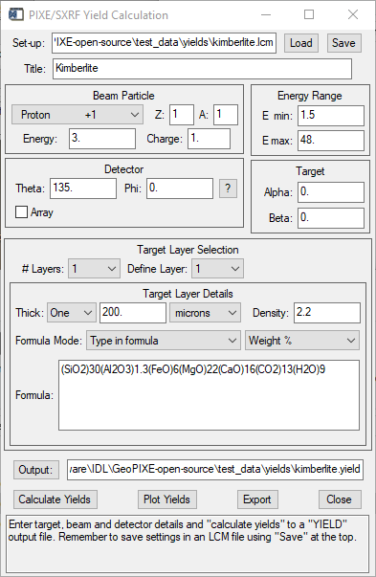

- Select “Calculate Yields” and make sure the output file “kimberlite.yield” is directed back into the same directory “test_data/yields”.
- Run the yield comparison tool using menu “TestsCompare Yields”.
  - Navigate to the “test_data/yields” directory and select the reference file “kimberlite-REF.yield” and your new output file “kimberlite.yield”.
  - This creates the output file “kimberlite.txt” in the same directory.
- If all is good, you should see a report like this:

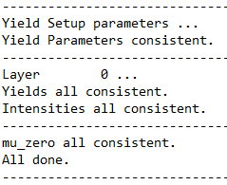

- If differences are found, they will be reported. Normally, this test is meant to detect inconsistencies due to changes in underlying routines and databases. However, as an example, if we did the modelling using a 2.95 MeV beam, it produces numerous differences, some of which are shown here …

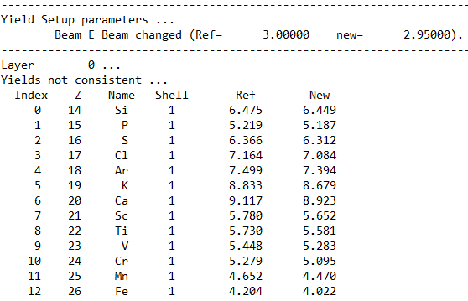
…
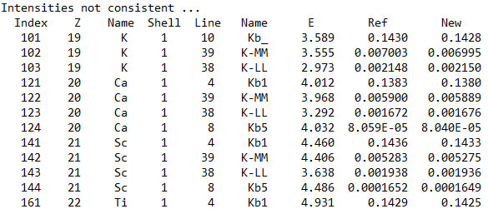
…

Simple SXRF yield model
- Open the yield calculation window using the menu “WindowPIXE/SXRF Yield Calculation” in the Spectrum Display window.
- Load the setup file “test_data/yields/hematite.lcm”, which is a simple single layer target, probed using a 15.2 keV mono-chromatic photon beam, for SXRF analysis, with the target inclined at 45° to the beam, and a simple generic detector at 85°.

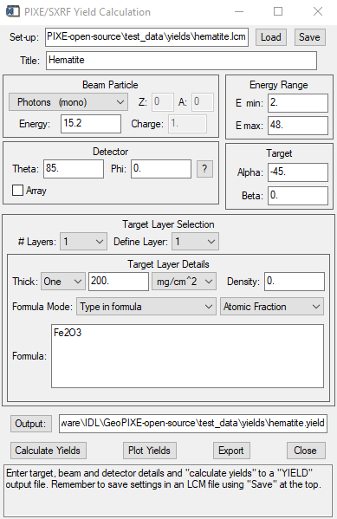

- Select “Calculate Yields” and make sure the output file “hematite.yield” is directed back into the same directory “test_data/yields”.
- Run the yield comparison tool using menu “TestsCompare Yields”.
  - Navigate to the “test_data/yields” directory and select the reference file “hematite-REF.yield” and your new output file “hematite.yield”.
  - This creates the output file “hematite.txt” in the same directory.
- If all is good, you should see a report like this:



- If differences are found, they will be reported. For example, if we did the modelling with the target at 40°, it produces numerous differences, some of which are shown here …

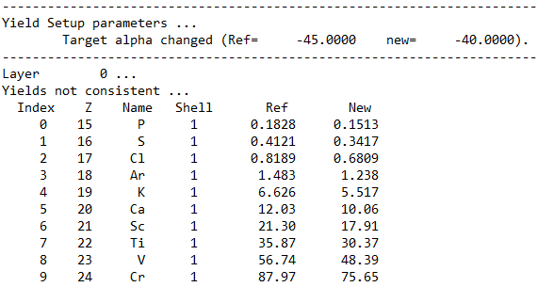
…
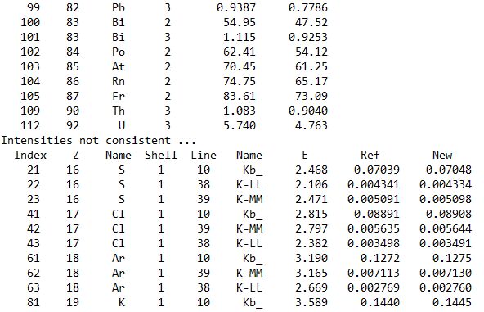
…

PIXE yield model for a fluid inclusion
- Open the yield calculation window using the menu “WindowPIXE/SXRF Yield Calculation” in the Spectrum Display window.
- Load the setup file “test_data/yields/inc-d10-t10.lcm”, which is a three-layer target to model the main 3-layer structure of a 10 μm fluid inclusion at a depth of 10 μm in a host mineral quartz, analyzed using a 3 MeV proton beam for PIXE analysis, and a simple generic detector at 135°.

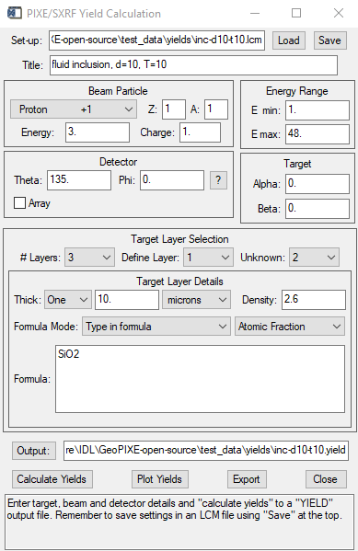

- Select “Calculate Yields” and make sure the output file “inc-d10-t10.yield” is directed back into the same directory “test_data/yields”.
- Run the yield comparison tool using menu “TestsCompare Yields”.
  - Navigate to the “test_data/yields” directory and select the reference file “inc-d10-t10-REF.yield” and your new output file “inc-d10-t10.yield”.
  - This creates the output file “inc-d10-t10.txt” in the same directory.
- If all is good, you should see a report like this:

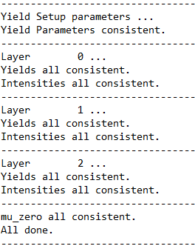

SXRF yield model using the Maia detector array
- Open the yield calculation window using the menu “WindowPIXE/SXRF Yield Calculation” in the Spectrum Display window.
- Load the setup file “test_data/yields/Shale_100um_SiO_1mm_384C14_18500eV.lcm”, which is a simple two-layer target, probed using a 18.5 keV mono-chromatic photon beam, for SXRF analysis, with the target normal to the beam (alpha = 0°), and using the Maia 384 detector array (revision C) at back angles, normal to the target (theta = 180°).

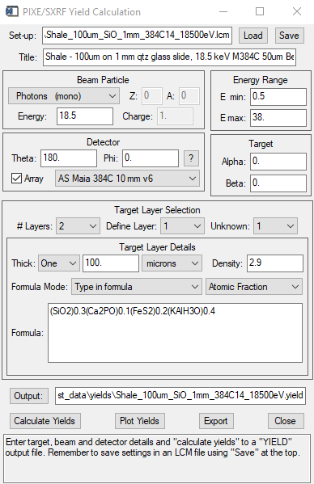

- Select “Calculate Yields” and make sure the output file “Shale_100um_SiO_1mm_384C14_18500eV.yield” is directed back into the same directory “test_data/yields”.
- Run the yield comparison tool using menu “TestsCompare Yields”.
  - Navigate to the “test_data/yields” directory and select the reference file “Shale_100um_SiO_1mm_384C14_18500eV-REF.yield” and your new output file “Shale_100um_SiO_1mm_384C14_18500eV.yield”.
  - This creates the output file “Shale_100um_SiO_1mm_384C14_18500eV.txt” in the same directory.
- If all is good, you should see a report like this:

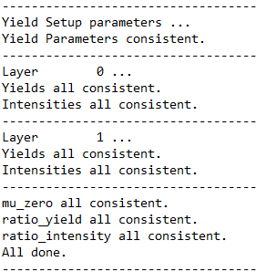

- If differences are found, they will be reported. Normally, this test is meant to detect inconsistencies due to changes in underlying routines and databases. However, as an example, if we did the modelling with a beam energy of 18.4 keV it produces numerous differences, some of which are shown here …

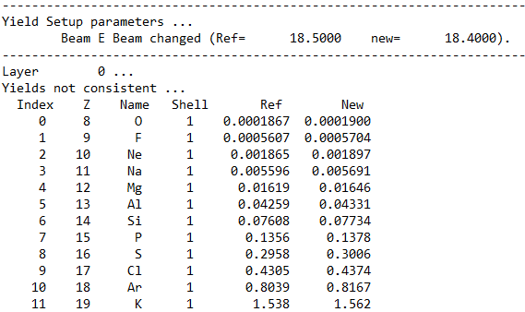
…
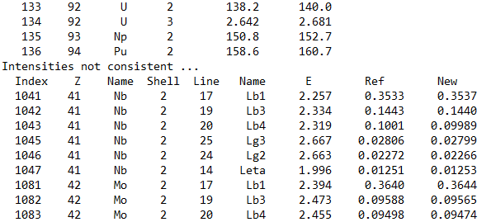
…
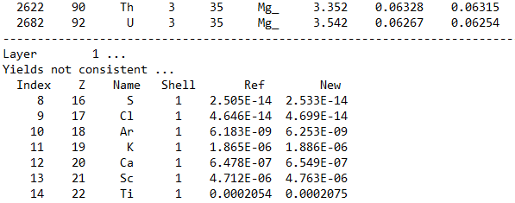
…
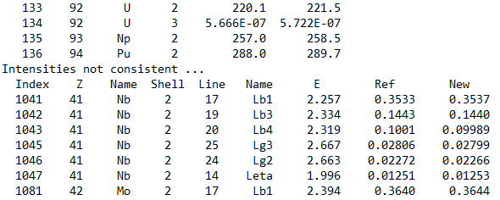
…
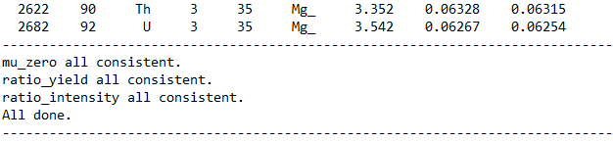

Yield model for Maia Mapper lab X-ray source using the Maia detector array
- Open the yield calculation window using the menu “WindowPIXE/SXRF Yield Calculation” in the Spectrum Display window.
- Load the setup file “test_data/yields/ rock-slab4-poly2.lcm”, which is a simple thick target, probed using a continuum photon beam from an Excillum D2+ high intensity microfocus X-ray source in the Maia Mapper instrument, for SXRF analysis, with the target normal to the beam (alpha = 0°), and using the Maia 384 detector array (revision D) at back angles, normal to the target (theta = 180°).

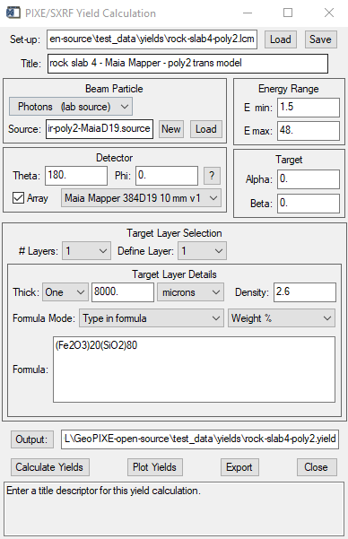

- Select “Calculate Yields” and make sure the output file “rock-slab4-poly2.yield” is directed back into the same directory “test_data/yields”.
- Run the yield comparison tool using menu “TestsCompare Yields”.
  - Navigate to the “test_data/yields” directory and select the reference file “rock-slab4-poly2-REF.yield” and your new output file “rock-slab4-poly2.yield”.
  - This creates the output file “rock-slab4-poly2.txt” in the same directory.
- If all is good, you should see a report like this:

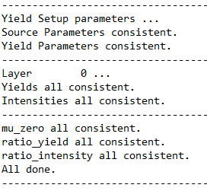

- If differences are found, they will be reported. Normally, this test is meant to detect inconsistencies due to changes in underlying routines and databases. However, as an example, if we did the modelling with a sample density of 2.5 g/cm² it produces numerous differences (even with a thick 8 mm target, heavy elements see this change in density, which effects the areal density of the target), some of which are shown here …

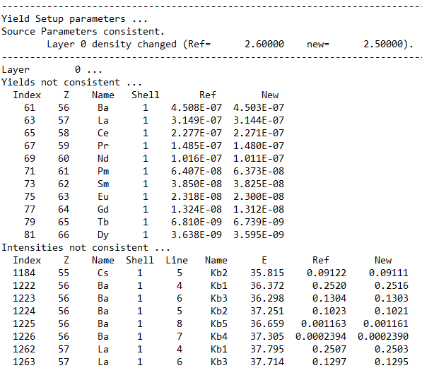
…
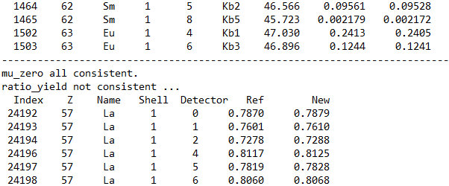
…
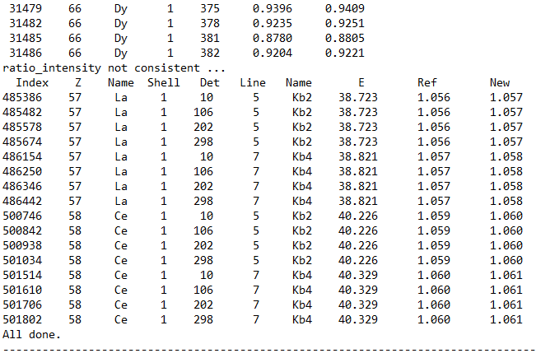

Source modelling
Here we’re looking at the modelling of the spectrum from a continuum laboratory X-ray source, including characteristic lines from anode materials. The ‘compare_sources’ routine looks for changes in input parameters, which will change the modelling results. These differences are reported in the output file. It then compares the output values for (i) the spectrum E vector and data, (ii) characteristic line content, and (iii) characteristic line relative intensities. Any differences typically beyond 0.1% are reported.

Maia Mapper source model
- Open the yield calculation window using the menu “WindowPIXE/SXRF Yield Calculation” in the Spectrum Display window.
- Load the setup file “test_data/yields/ rock-slab4-poly2.lcm”, which is a simple thick target, probed using a continuum photon beam from an Excillum D2+ high intensity microfocus X-ray source in the Maia Mapper instrument.
- The source is set to “Photons (lab source)”. Next to “Source”, select “New” to open the Source Setup & Edit window.
- Load the setup file “test_data/sources/Excillum-70kV-200W-1-Al-2mm-air-poly2-MaiaD19-REF.source”, which defines the conditions for the Excillum D2+ X-ray source using the I2 alloy extruded liquid metal jet (and the electron beam and metal jet geometry), an inline XOS polycapillary lens and hardening filters.
- Select “Save” to trigger a recalculation of the spectrum and save to file “test_data/sources/Excillum-70kV-200W-1-Al-2mm-air-poly2-MaiaD19.source”.
  - Be careful NOT to write over the original -REF.source file.
- Run the source comparison tool using menu “TestsCompare Sources”.
  - Navigate to the “test_data/sources” directory and select the reference file “Excillum-70kV-200W-1-Al-2mm-air-poly2-MaiaD19-REF.source” and your new output file “Excillum-70kV-200W-1-Al-2mm-air-poly2-MaiaD19.source”.
  - This creates the output file “Excillum-70kV-200W-1-Al-2mm-air-poly2-MaiaD19.txt” in the same directory.
- If all is good, you should see a report like this:

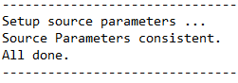

- If differences are found, they will be reported. Normally, this test is meant to detect inconsistencies due to changes in underlying routines and databases. However, as an example, if we did the modelling with a source HV of 71 kV it produces numerous differences, some of which are shown here …

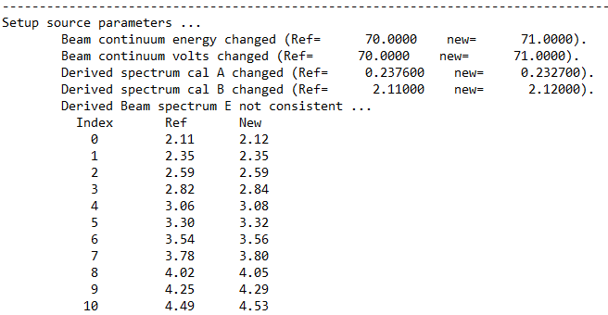
…
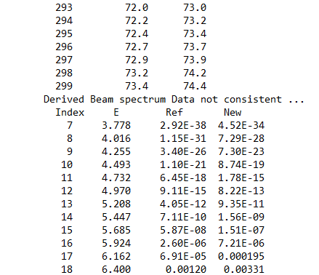
…
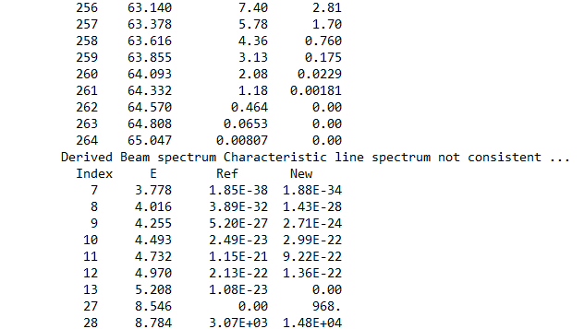
…
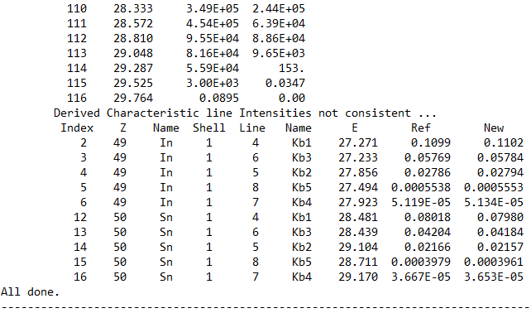

Spectrum fitting
Here we’re looking at the least squares fitting of a fluorescence spectrum using a fitting model comprising (i) a background estimation (using SNIP of SNP & Bayer), (ii) characteristic element X-ray lines, corrected for filters and detector efficiency, including escape peaks and optional tailing (iii) a pileup model to 3rd order, constructed from the most intense lines, and (iv) Compton scatter lines including multiple scattering tails, in the case of a photon beam. X-ray line shapes are influenced by energy calibration and FWHM parametrizations, which are also refined in the fit.

To test fitting we need to combine (i) some spectrum data, (ii) a fit setup for the X-ray Spectrum Fit window, including element selection, energy range and fitting parameter options, and (iii) a pre-calculated yield model (referenced in the fit setup).

The ‘compare_fits’ routine looks for changes in input parameters, which will change the fitting or concentration results. These differences are reported in the output file. It then compares the output values for (i) the rGamma relative sensitivity factor array, across all detectors (ii) the source spectrum (calls ‘compare_source’ or ‘compare_pink’), if relevant to yields, and (iii) the yield factors ‘counts_per_ppm_uc’, and (iv) results for ‘conc, ‘err’, ‘MDL’ and peak ‘Area’. Any differences typically beyond 0.1% for the model data and 3% for the fitting are reported.

PIXE spectrum fit
- Load the spectrum file “test_data/fits/CSIRO/donut2x-2-whole.spec” into Spectrum Display.
- Open the X-ray Spectrum Fit window, using the menu “Window X-ray Spectrum Fit” in the Spectrum Display window, if it’s not already open.
- Load the fit setup file “test_data/fits/CSIRO/donut2x.pcm” using the “Load” button at the top of X-ray Spectrum Fit.
  - This should have found the yields file “test_data/fits/CSIRO/kimberlite.yield”.
  - Click “Fit One” to fit the spectrum.
- Open the Fit Results window (menu “WindowsFit Results”).
  - This should show 1 row for this spectrum.
  - Click “Save” and save the results to file “test_data/fits/CSIRO/donut2x-2-whole.pfr”.
- Run the fit comparison tool using menu “TestsCompare Fits”.
  - Navigate to the “test_data/fits/CSIRO” directory and select the reference file “donut2x-2-whole-REF.pfr” and your new fit results file “donut2x-2-whole.pfr”.
  - This creates the output file “donut2x-2-whole.txt” in the same directory.
- If all is good, you should see a report like this:

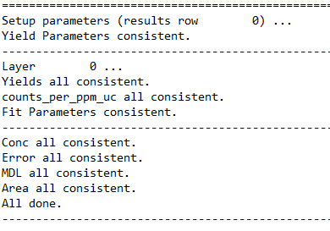

- If differences are found, they will be reported. Normally, this test is meant to detect inconsistencies due to changes in fitting or the underlying routines and databases. However, as an example, if we did the modelling with a small change in filter (200 μm Al replaced with 194 μm Al) it produces numerous differences, some of which are shown here …

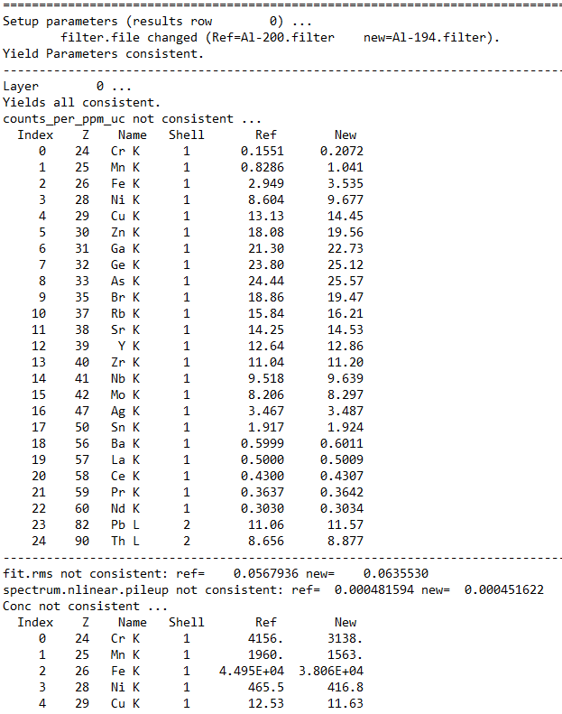
…
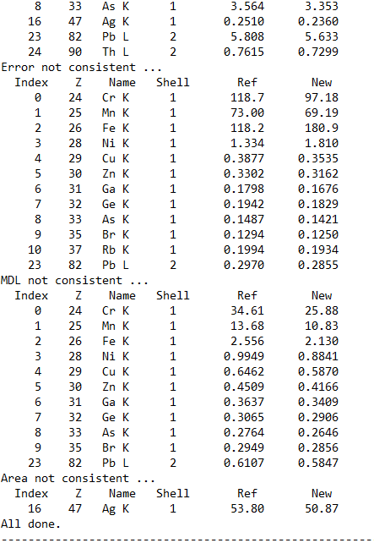

SXRF spectrum array fit
- Load the spectrum file “test_data/fits/APS/pncid_0082-E.spec” into Spectrum Display.
- Open the X-ray Spectrum Fit window, using the menu “Window X-ray Spectrum Fit” in the Spectrum Display window, if it’s not already open.
- Load the fit setup file “test_data/fits/APS/hematite-array.pcm” using the “Load” button at the top of X-ray Spectrum Fit.
  - This should have found the yields file “test_data/fits/APS/hematite-array.yield”.
  - Click “Fit All” to fit all 8 spectra.
- Open the Fit Results window (menu “WindowsFit Results”).
  - This should show 8 rows, one for each spectrum.
  - Click “Save” and save the results to file “test_data/fits/APS/pncid_0082-E.pfr”.
- Run the fit comparison tool using menu “TestsCompare Fits”.
  - Navigate to the “test_data/fits/APS” directory and select the reference file “pncid_0082-E-REF.pfr” and your new fit results file “pncid_0082-E.pfr”.
  - This creates the output file “pncid_0082-E.txt” in the same directory.
- If all is good, you should see a report like this (repeated for all 8 detectors):

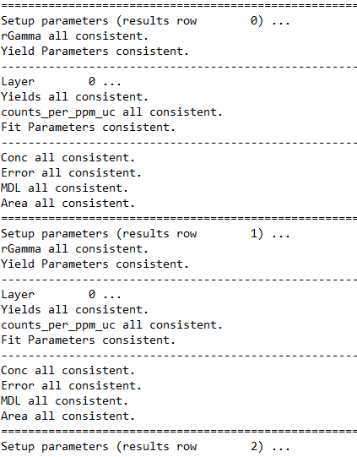
…

- If differences are found, they will be reported. Normally, this test is meant to detect inconsistencies due to changes in fitting or the underlying routines and databases. However, as an example, if we did the modelling with a target angle of -44°, it produces numerous differences, some of which are shown here (and repeated across 8 rows) …




